25. Inheritance in AEM

* One of the powerful feature in AEM is to inherit from existing components.
* Example there is a Page component that comes with the AEM and we can inherit all the functionalities that's already prebuilt in that page component into our own page rendering component.

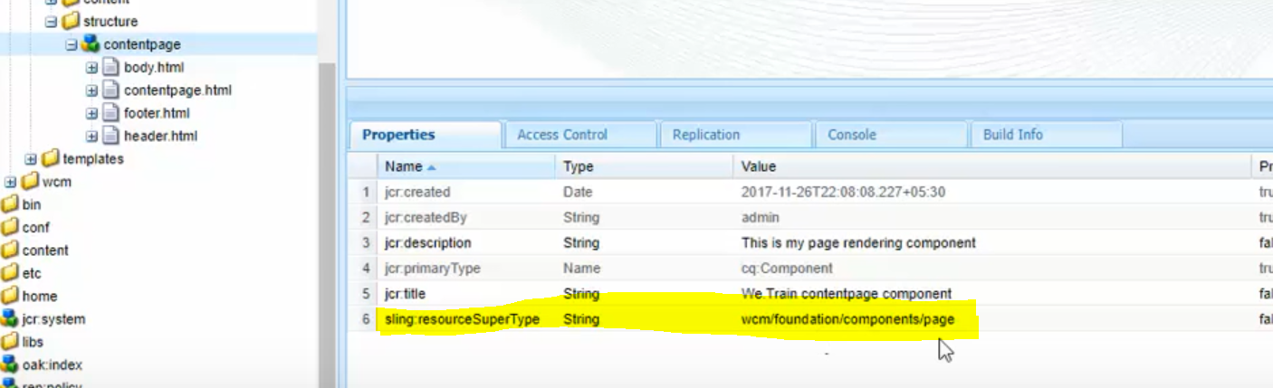

* Defining the property “**sling:resourceSuperType**” enables inheritance from a super type.

As we have mentioned that the parent of this particular contentpage component is wcm/foundation/components, though we have not created any dialog inside contentpage component, we are still able to see the page properties.

Sling will look for dialog in the parent component, if it doesn’t find it in the child component.

It applies for scripts as well. Even if we delete contentpage.html from here, still the body.html would be referred from child component. Because, when sling doesn’t find conentpage.html, it looks for the sling:resourceSuperType mentioned on the component (libs/wcm/foundation/components/page/page.html).

page.html would get executed and as it finds “body.html” getting included, it looks for the same in contentpage component and executes it.



* AEM provides foundation components which are made up of sightly in **/libs/wcm/foundation/components** and jsp components in **/libs/foundation/components**.
* When there is no script found in the components then sling looks for sling:resourceSuperType property and and finds the default script in the super component.

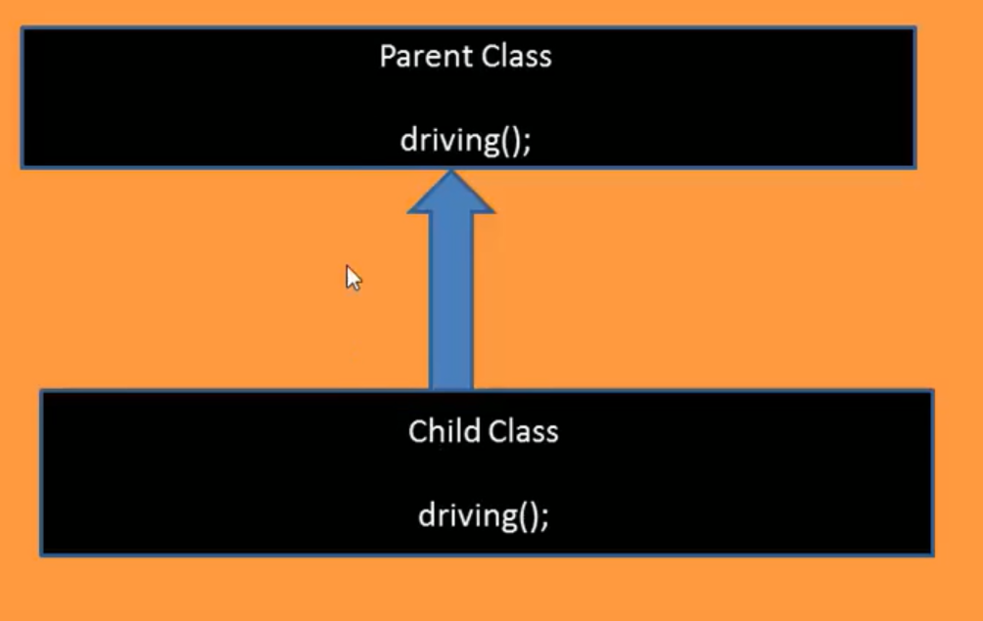

Child method would be given priority over the parent method. Same applies in case of inheritance in AEM. If some script or dialog is not found in the child, then only it looks for the parent.